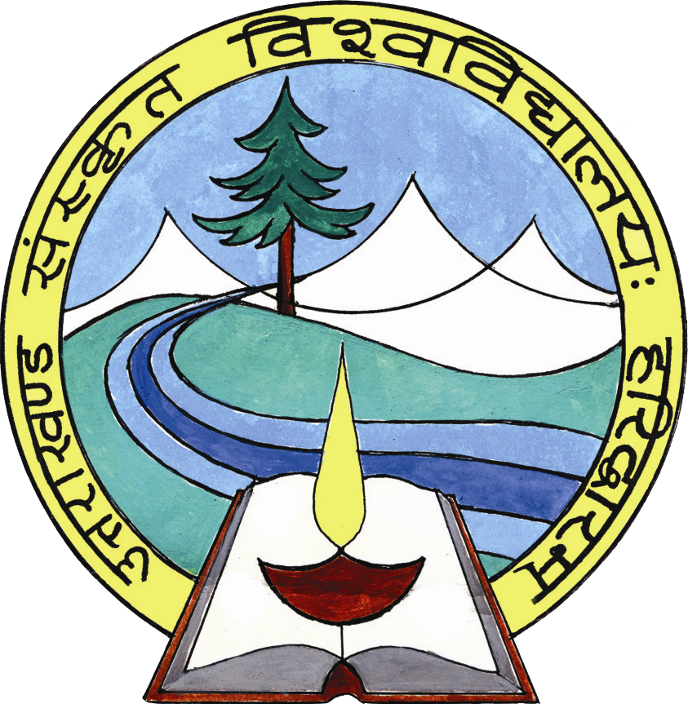

UTTARAKHAND SANSKRIT UNIVERSITY
Nh-58, BHEL Turn, Bahadrabad, Haridwar-249402, Uttarakhand

Feedback from Alumni
(Filled feedback form, send to iqacusvv@gmail.com, iqac@usvv.ac.in)

Name: Mr./Ms/Mrs. -----------------------------------------Age (years): -------------Sex (M/F): -----------------
Dept.: ---------------------------------Year of Study: ------------Occupation: -----------------------------------------
Address: -----------------------------------------------------------Mobile -------------------- E-mail ------------------

Make a tick () mark in the appropriate cell :

Sl.  # | Particulars | Strongly agree | Agree | Neutral | Disagree | Strongly disagree
1 | I feel proud to be the student of SLBSRSV
2 | The learning I had inthe University is useful in my career.
3 | The developments inthe University in recent years are appreciative.
4 | The new courses introduced meet contemporary requirements.
5 | SLBSRSV is involving alumni in its activities.
6 | The alumni have a role to play in academically strengthening the University further.
7 | The alumni have a role to play in financially strengthening the University.
8 | Formation of Department wise alumni associations is a step in the right direction.
9 | The Department administration should take initiative to efficiently enroll and strengthen the alumni-association.

Suggestions for further improvement:

------------------------------------------------------------------------------------------------------------------ -----------

------------------------------------------------------------------------------------------------------------------ -----------

------------------------------------------------------------------------------------------------------------------ -----------

------------------------------------------------------------------------------------------------------------------ -----------

